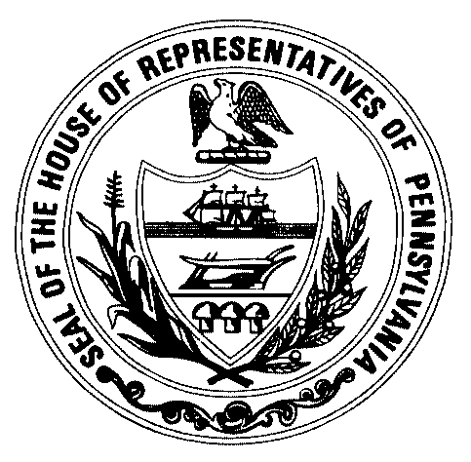 | HOUSE  Republican Policy Committee  Hon. Stanley E. Saylor  Chairman | House Box 202094  Harrisburg, PA 17120  (717)787-0159  www.pagoppolicy.com
Andrew J. Ritter Jr.
Executive Director
aritter@pahousegop.com

OIL REGION ALLIANCE

OCTOBER 28, 2009

FRANKLIN CLUB
FRANKLIN, PA

- WELCOME ~12:30 p.m.
- INTRODUCTION OF HOUSE MEMBER ATTENDEES
– REP. STAN SAYLOR, CHAIR
- INTRODUCTION OF ATTENDEES FROM THE NORTHWEST ECONOMIC DEVELOPMENT AGENCIES
– RANDY SEITZ, PRESIDENT, OIL REGION ALLIANCE (ORA)

- ECONOMIC DEVELOPMENT ISSUES IN THE NORTHWEST
- OIL REGION ECONOMIC HISTORY– RANDY SEITZ
- ISSUES UNIQUE TO THE NORTHWEST
- IMPACT OF THE CURRENT ECONOMIC CRISIS
- VISION OF THE FUTURE IF ACTION IS NOT TAKEN

- ROLE OF THE COMMONWEALTH
- BUSINESS DEVELOPER POINT OF VIEW
- STRENGTHS AND WEAKNESSES.

- ROLE OF LOCAL GOVERNMENT
- BUSINESS DEVELOPER POINT OF VIEW.
- STRENGTHS AND WEAKNESSES.

- ECONOMIC DEVELOPMENT PROJECTS IN THE REGION
(LIST EXAMPLES FOR PRESENTATION AND DESCRIBE THE ROLES PLAYED BY STATE AND LOCAL GOVERNMENT AS DISCUSSED ABOVE)

- DISCUSSION
- HOW TO BETTER UTILIZE THE STATE PROGRAMS TO GROW RURAL PENNSYLVANIA.
- ACCESS TO CURRENT PROGRAMS
- A+B=REFORM

GROUP TOUR

